Take Home Exam 12: C-rate

## Assigned: Nov 11/28

Due (as pdf by email) 12/02/22 (Friday) -please adhere to this deadline.

HW 12

This homework is based on the lecture on Monday 11/28, which will not be posted. Therefore please take notes. The homework simply asks you to answer the problem which was analyzed in class but in your own words.

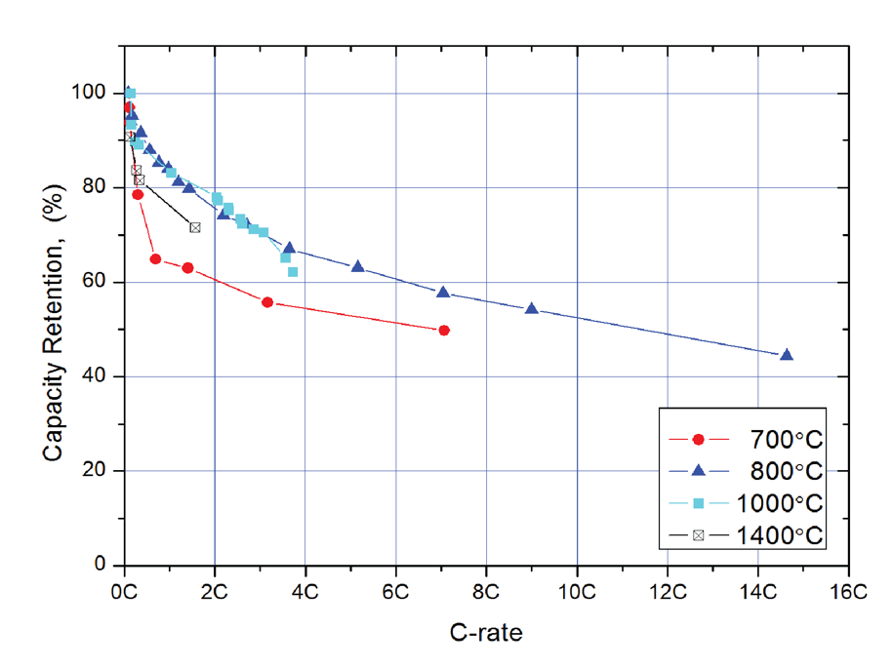What is C-rate: It is the number of cycles per hour. For example a C-rate of 20 h–1 implies a cycle time (charge and discharge) of 3 minutes, etc.

The effective capacity of the anode declines as the rate is increased as shown below:

Different data sets in the figure refer to materials processed in different ways. But they all show the same trend.

The problem is to derive and expression that is consistent with the trend line for the decline in the capacity at higher C-rates.

The Approach

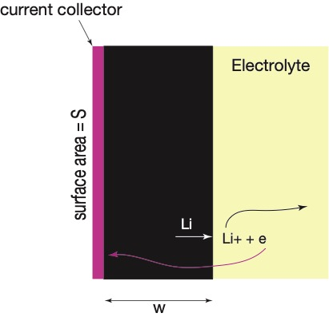For simplicity, consider a monolithic anode as shown below. It has a width of  and a surface area of S. The distance from which Li is drained from the anode depends on the diffusion distance, which is related to the coefficient of diffusion as follows

 (1)

The Analysis

In the figure given above 100% refers to the full width of the anode being engaged in the discharge capacity.

Draw normalized parameters to express the C-rate in terms of the parameters in Eq. (1) to show the dependence of the effective capacity as a function of the C-rate. In particular aim for the shape expressed in the experimental results.